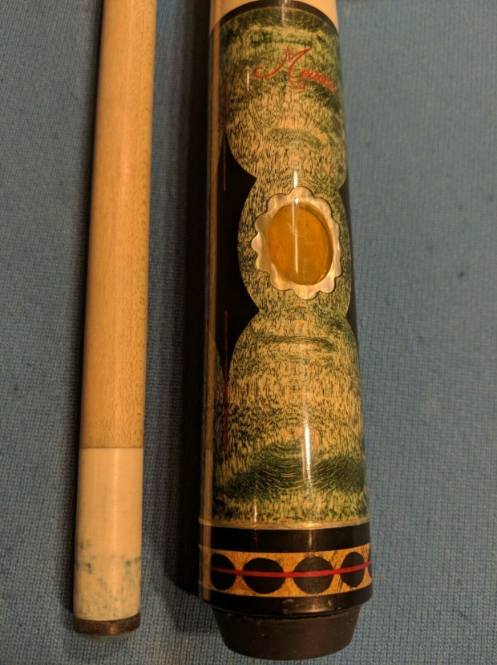
Older Meucci WS-7 Pool Cue - Winter Series highest

iTem price $314.99
number 283481852851
Shipping USPS Priority Mail

Plus shipping 933.00

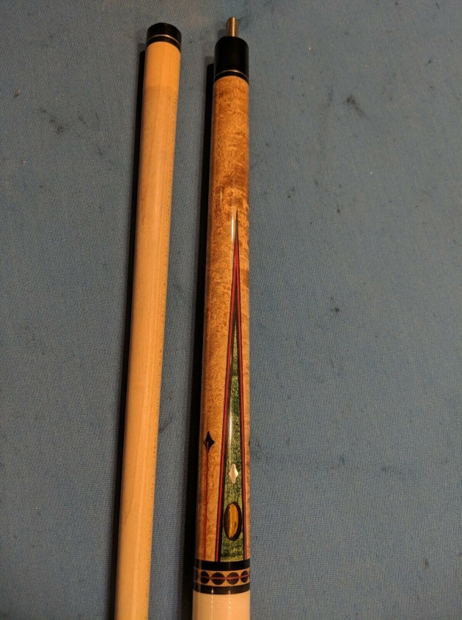
Pretty elaborate older Meucci, as far as I can tell a 1996 WS-7, top of the Winter Series line.
The meucci script logo is in red......couldnt figure out exactly what that signifies.....if anyone knows and wouldnt might dropping me a note, I would love to know.
Condition: There are two light red marks on the shaft closer to joint, from what I have no idea. There is one light mark on shaft, a little dent on butt sleeve, a couple little marks on wrap, can see bluing on shaft.....thats all I could see to note. Please see photos as all these items, and all sides of the entire cue are in the photos.
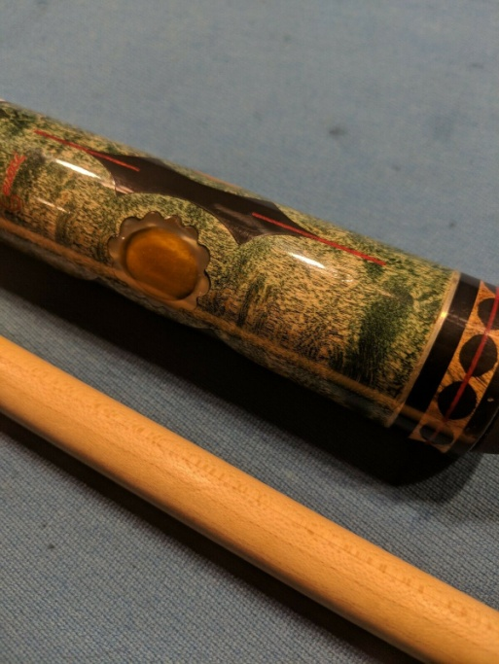
Butt and shaft both roll straight and smooth. HOWEVER, when assembled the shaft exhibits a run of the mill taper roll.....the reason for this seems to be that shaft seems to be a hair off joining up to the butt....please see the close up pic of the joint. Not sure what that takes to fix if one wished to. Cue still rolls and plays fine in my opinion.
Bumper might not be the right one shimmed with a little paper......either its not the right one, or the quality control had a bad day that day. Bumper covers an old looking weight bolt.
Some spots of the rings and inlays can very slightly be felt.
3.7oz shaft, butt 16.6, 20.4 together. 13.1mm tip, butt is 28 3/4", shaft is 29 1/16".
Insured and shipped to lower 48 CONUS only.

